**MARWADI FOOD**

## A PROJECT REPORT

***Submitted by***

## MOHAMMAD ASIF RAJA

### 919001030123

## BACHELOR OF TECHNOLOGY

***in***

### Computer Engineering



## Marwadi University, Rajkot

**November , 2022**



## Marwadi University

**Rajkot**

# CERTIFICATE

# 

This is to certify that the project report submitted along with the project entitled **Marwadi Food** has been carried out by **Mohammad Asif Raja (91900103123)** under my guidance in partial fulfilment for the degree of Bachelor of Technology in Computer Engineering, 7th Semester of Marwadi University, Rajkot during the academic year 2022-23.

Jaydeep Ratanpara Prof. Hardik Doshi

Internal Guide Head of the Department

### 

## Marwadi University

**Rajkot**

# DECLARATION

We hereby declare that the Major Project-I report submitted along with the Project entitled

**Marwadi Food** submitted in partial fulfilment for the degree of Bachelor of Technology in Computer Engineering to Marwadi University, Rajkot, is a bonafide record of original project work carried out by me / us at Marwadi University under the supervision of **Jaydeep Ratanpara** and that no part of this report has been directly copied from any students’ reports or taken from any other source, without providing due reference.

Name of the Student Sign of Student

Mohammad Asif Raja ___________

**Acknowledgement**

In the accomplishment of completion of my project Marwadi Food. I would like to convey my special gratitude to Mr. Jaydeep Ratanpara of Computer Engineering and as well as Mr. Hardik Doshi (Head of Department) of Computer Engineering, Marwadi University.

Your valuable guidance and suggestions helped me in various phases of the completion of this project. I will always be thankful to you in this regard. I would like to extend my deep appreciation to all my mentor without whose support and coordination I would not have been able to complete this project.

I am ensuring that this project was finished by me and has not been copied or duplicated from any other sources.

Mohammad Asif Raja

**Abstract**

People around the world are busy in their life. Busy enough to not have time to go and check the daily food menu. My motivation for the proposed system comes from the people around me trying to find menu and order food from Marwadi University mesh. The proposed system is motivated from people who are facing problems regarding our mesh facilities.

Our website will take care of feedback of the food consumers as there was no any proper review system earlier in our university. Earlier if there were any changes made in the food menu then there were no any updates made or no any notification in the existing systems so the consumers would have to face various problems. The User Interface (UI) of previous system were not so interactive and informative to the users.There were no any proper facilities to inform food department about the student/consumers information when they were having some health issues due to which they were unable to have meals at proper time leading further illness to the consumer. The previous system were only targeted to hostel students neglecting the other consumers like faculties and out of hostel students.

### List of Figures

Fig 1.1 Project Scheduling Gantt’s Chart..................................................................... 4

Fig 2.1 Proposed System.............................................................................................. 6

Fig 3.1 DFD Level 0..................................................................................................... 8

Fig 3.2 DFD Level 1................................................................................................... .9

Fig 3.3 ER Diagram.................................................................................................... 10

Fig 3.5 Database Tables…………………………………………………………… 11

Fig 3.6 Database User_Data Table………………………………………………….11

### List of Tables

Table 1.1 Effort Estimation ......................................................................................... 3

**List of Abbreviations**

**GUI (Graphical User Interface)**

**CBSE (Component Based Software Engineering)(**

**SDLC (Software Development Life Cycle)**

**IDE (Integrated Development Environment)**

**DB (Database)**

**DFD (Data Flow Diagram)**

**ER (Entity Relationship Diagram**)

### Table of Contents

Acknowledgement.................................................................................................................. ii

Abstract .............................................................................................................................…iii

List of Figures ....................................................................................................................…v

List of Tables ...................................................................................................................… vi

List of Abbreviations .............................................................................................................vi Table of Contents .................................................................................................................vii

Chapter 1 Introduction to Project and Project Management...................................................1

1.1 Project Summary...............................................................................................................1

1.2 Purpose..............................................................................................................................1

1.3 Objective...........................................................................................................................1

1.4 Scope.................................................................................................................................2

1.5 Technology and Literature Review...................................................................................2

1.6 Project Planning................................................................................................................3

1.6.1 Project Development Approach and Justification.................................................3

1.6.2 Project Effort and Time, Cost Estimation.......................................................… 4

1.6.3 Roles and Responsibilities...............................................................................… 4

1.7 Project Scheduling (Gantt Chart/PERT/Network Chart) ............................................… 4

Chapter 2 System Analysis................................................................................................… 5

2.1 Study of Current System ........................................................................................……. 5

2.2 Problem and Weaknesses of Current System .........................................................…... 5

2.3 Requirements of New System ....................................................................................… 6

2.4 System Feasibility

2.4.1 Can the system be implemented using the current technology and within the given cost and schedule constraints …………………………………………………6

2.4.2 Can the system be integrated with other systems which are already in place?..6

2.5 Features of New System / Proposed System…………………………………………..7

2.6 Selection of Hardware / Software / Algorithms / Methodology / Techniques ………..7

Chapter 3 System Design..................................................................................................... 8

3.1 System Design & Methodology ……………………………………………………….8

3.2 Database Design……………………………………………………………………….10

3.3 Input / Output and Interface Design…………………………………………………. 12

Chapter 4 Implementation.................................................................................................... 13

4.1 Implementation Platform / Environment

Chapter 5 Testing………...................................................................................................... 13

5.1 Testing Plan / Strategy

5.2 Test Results and Analysis

5.2.1 Test Cases (test ID, test condition, expected output, actual output, remark)….14

Chapter 6 Conclusion and Discussion...................................................................................11

6.1 Overall Analysis of Project Viabilities ………………………………………… 15

6.2 Problem Encountered and Possible Solutions ………………………………… 15

6.3 Summary of Project work ………………………………………………………16

6.4 Limitation and Future Enhancement…………………………………………… 16

References.........................................................................................................................…17

**Chapter 1: Introduction to Project and Project Management**

**1.1 Project Summary**

The project is titled Marwadi Food and is a food website that aims in helping the users to know the daily menu of our university mesh. It has nice user interface and provide smooth flow of the user’s interaction. The platform uses advance methods to improve the bugs and make it more responsive that are currently present in the existing system. This project contributes to the resolution of most of the issues associated with the existing system in the same domain. The main goal of the project is to save the time of the users in hostel who are accessing the international mesh of our university.

**1.2 Purpose**

The purpose of this project is to build an online web application using PHP, HTML, CSS, Javascript and other technologies with functionalities such as profile creation, daily food menu gallery, food request system, special menu list and many more.

**1.3 Objective**

The main objective of the project is to achieve the following:

* To increase the range of users like including faculties and guest.
* To save the time of the students who are unable to visit mesh to eat food
* To create direct connection between the admin i.e the food department and the students.

**1.4 Scope**

This project helps solve most of the problems that has been associated with the existing system in the same domain. The main objective of the project is to save the time of the mesh user of our university.In order to develop the application, use of technology like PHP, HTML, CSS, Javascript etc would be done.

**1.5 Technology and Literature Review**

The system uses following technology as its main component for development

* PHP
* HTML
* CSS
* Javascript
* Mysql

**Literature review**

Previous and some existing food menu and food order system-

1. Self Serviced Restaurant

To cover the limitations of the manual restaurant system self service restaurant was introduced. There are a lot of drawback of manual system like, wastage of time and money. A lot amount of effort is required for the small change. In the proposed system every customer goes to the restaurant and place order in the service counter, customer have to take decision in advance, and customer either select item form of poster and placing normally behind the order corner.

1. Conventional Paper Based System

Paper based system is widely most widely used food ordering and menu system in the past

In this system customer has to go to the restaurant or canteen and waiter takes order form the customer and writes down in the paper. In this system each and every type of record is stored on the paper.

**1.6 Project Planning**

**1.6.1 Project Development Approach and Justification**

The project has been developed using technology like PHP, HTML, CSS, Javascript etc following the waterfall software development life cycle methodologies. Depending upon the requirement and time constraint of the project the methodologies may have adapted using waterfall SDLC with iterative, incremental and agile approaches. The adaptation might have occurred due to when the development has been broken into CBSE or due to factors like time.

The traditional waterfall model is used when the scope of the project is well known, has small risk, and requires minimal feedback during the development of the life cycle. Since the scope of the project is well known the changes cannot be made easily during the development of the software. It is usually not suitable for large projects. Here since the project is not that large waterfall model has been used. Sometimes we had to change the scope and make changes on the project for which different feedback were taken into consideration hence use of iterative approach has also been done. The project will also in near future use the incremental model where the application shall be updated and have better functionalities.

**1.6.2 Project Effort and Time, Cost Estimation**

The project has been done by two members. The project effort estimation has been done based on the task that has to be done in order to complete the project. Following table shows the effort estimation of the project

Table 1.1 Effort Estimation

|  |  |
| --- | --- |
| **Task** | **Days** |
| Planning | 7 |
| Research | 10 |
| Design | 50 |
| Implementation | 20 |
| **Total** | 87 |

A minimum of 87 days effort was required to complete the project but may have varied due to various factors. The cost of the project has not been estimated and does include a business model, but if estimated roughly based on the days of work required and the number of lines of code written, the project can be estimated to have cost 20k rupees. The project does not make any use of commercial software or product so far.

**1.6.3 Roles and Responsibilities**

The project is two member based project, so the roles and responsibilities of the project has all been assigned to the both creators of the project which includes developer, manager, analyst, quality control etc.

**1.7 Project Scheduling**

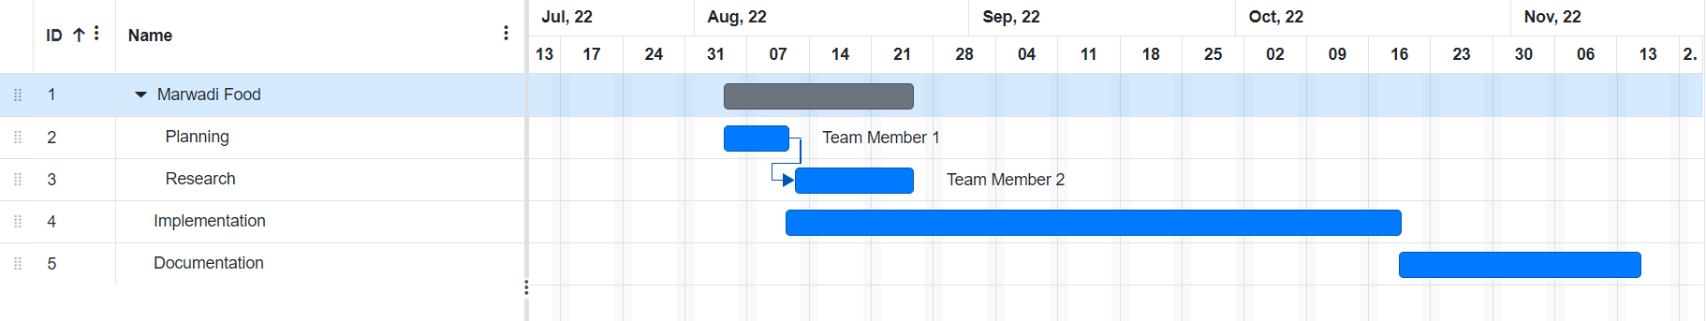

Fig 1.1 Project Scheduling Gantt’s Chart

**Chapter 2: System Analysis**

**2.1 Study of Current System**

There are many systems available in the market that provide feature of the food ordering system and food menu display. Some of them includes Zomato, MU Food and etc. All these systems have a common goal of delivering the food to the required consumers and notifies the daily food menu. The system includes different features like user login, location services and so on. The application also provides user interface which is somehow interactive in nature and engages the user.These functions are useful but the applications lags and are not up to the mark like they are not upgraded as the days changes or any changes occurred. They are less user interactive applications.

**2.2 Problem and Weaknesses of Current System**

The weakness of the existing system includes the following:

* **Drawbacks of existing system**
* No regular upgradation in the menu.
* Less user interactive.
* Less variety of users.
* Many bugs and glitches.
* No ordering systems for consumers in hostel.

**2.3 Requirements of New System**

There are currently many system available in the market. The solution has their own pros and cons. The existing system has been used by many but under the pressuring circumstances which can be overcome by the proposed system. The available solution to online daily food menu and food ordering system has given good benefits, but it comes with much more drawbacks of their own like high price for using the services available on the platform and also the less range of users for the application. The drawbacks can be one of the many reasons to have a new system proposed.

**2.4 System Feasibility**

**2.4.1 Can the system be implemented using the current technology and within the given cost and schedule constraints**

The proposed system can be fully implemented using the current technology that is available. The system uses a simple yet powerful technologies like PHP, html, css, javascript, mysql, which are easily available. The project has a time period of 87 days for an individual and estimated cost of 20k rupees, as the project is just an implementation and has no business model. The cost and effort of the project can be surely reducing if a group of experts are to be working on it.

**2.4.2 Can the system be integrated with other systems which are already in place?**

The proposed system is flexible, and its main components or ideas can be easily integrated with the existing system as it has been made using simple and multi-platform technology.

**2.5 Features of New System / Proposed System**

The proposed system has the following features:

* Profile Creation for the Users
* Daily food menu with images
* Feedback
* Social interaction with the team

**2.6 Selection of Hardware / Software / Algorithms / Methodology / Techniques**

The hardware selection includes the windows 11 running system and the internet, while the software selection includes IDE for application development, Visual Studio Code, Xampp etc. Methodology of the system includes the following:

**Problem Identification:**

The problem has been identified through people experience and different research works done by members with the students and faculties included.

**Problem Solution:**

The initial outcome of the identification was that we need to increase the range of the user like previously applications were focused for students only so now we included the faculties and the guest as well. Then the interface was also the aspect where wee needed to focus more like we needed to make it more user interactive so that we can make more and more user friendly application.

For this purpose we also included the food requesting system where the users can order the meal if they are unable to go to the mesh to eat due to their own problems.

**Chapter 3 System Design**

**3.1 System Design & Methodology**

The system design includes the process of implementation of the system. The system design can be of different types such as Logical View, Physical View and Architectural Design. Here the system design of the proposed system has been shown using the Logical view of the system using different diagrams such as the DFD, Use-Case Diagram.

Data Flow Diagram or DFD in short are diagrams that shows the flow of the data in the system. It uses defined symbols like rectangles, circles and arrows, plus short text labels, to show data inputs, outputs, storage points and the routes between each destination. Each circle or rectangles represent a process that is the part of the system. DFD can be multi-level, each level shows the increase in the complexity i.e., the detailed view of the system design. Here we have used DFD till level 1 which shows the overall design of data flow in the system.

DFD: Level – 0

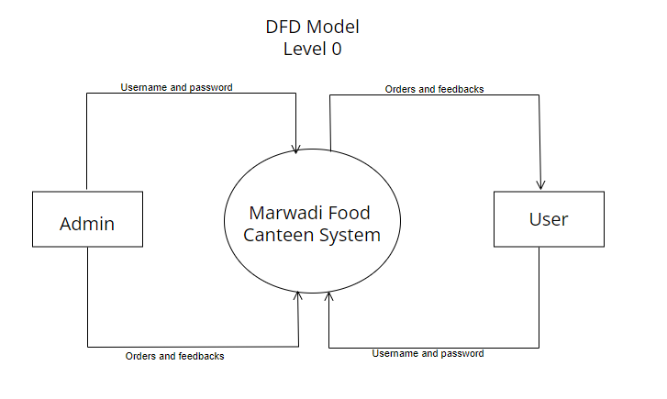

Fig 3.1 DFD Level 0

DFD: Level 1

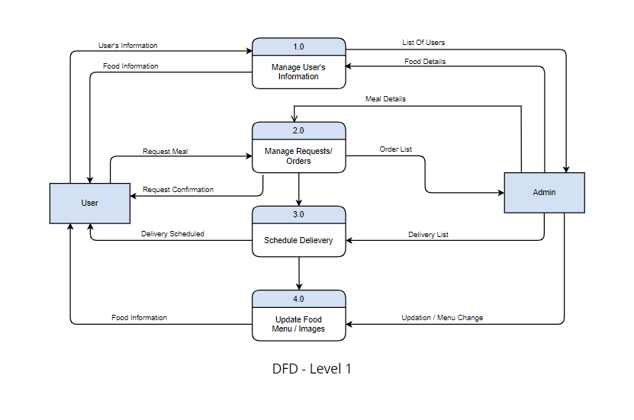

Fig 3.2 DFD Level 1

**3.2 Database Design**

The database is the collection of data in an organized format. It can be used to store and retrieve data to and from the database. The database design is represented by the ER Diagram. The database design for the system is shown using the ER diagram below

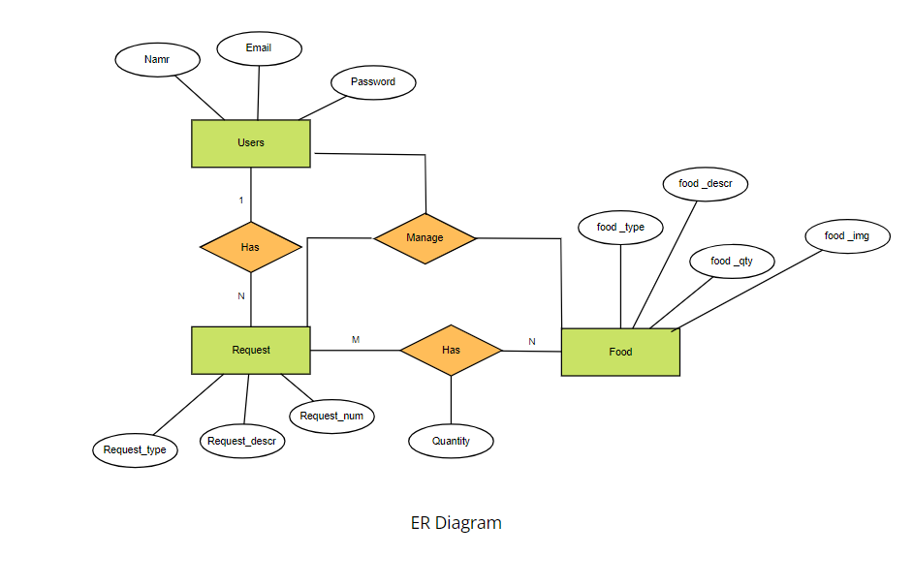

Fig 3.3 ER - Diagram

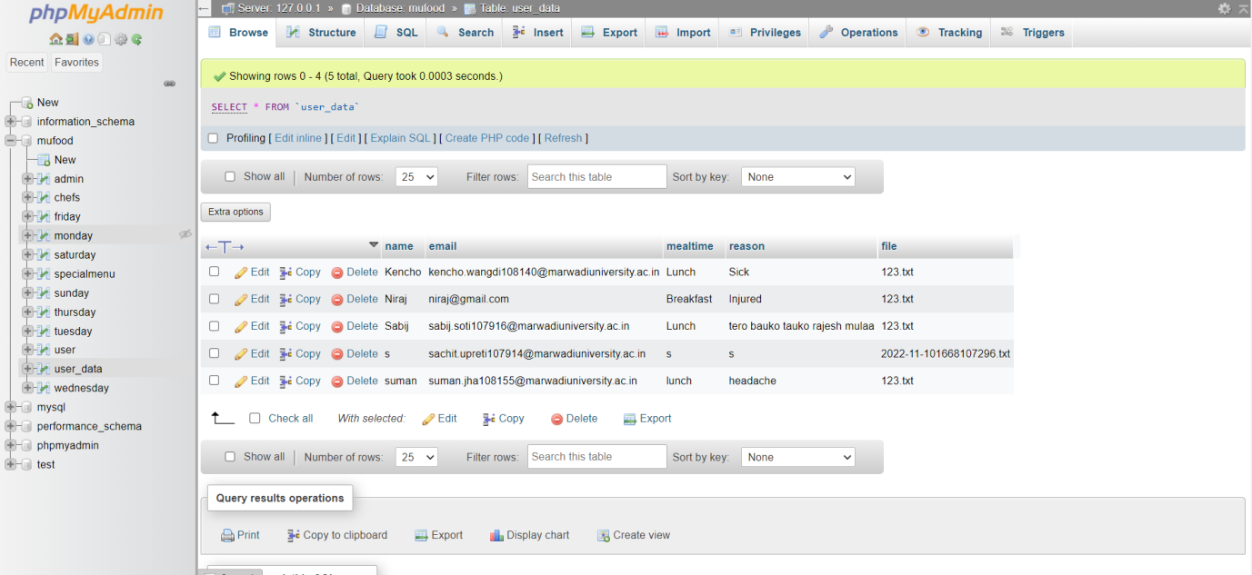

Fig 3.5 Database Tables

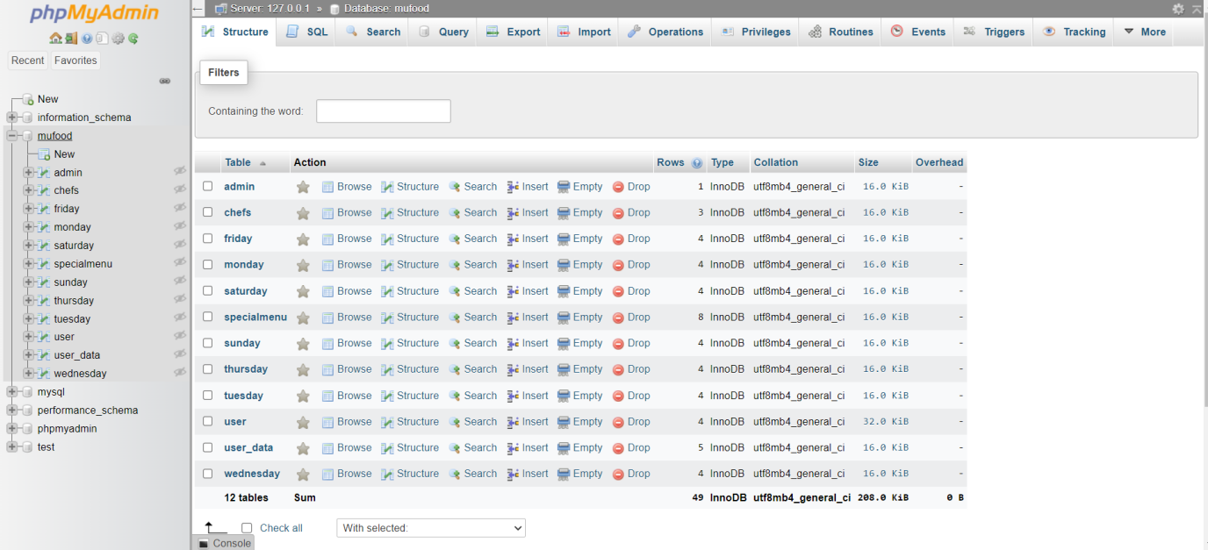

Fig 3.6 Database User_Data Table

**3.3 Input / Output and Interface Design**

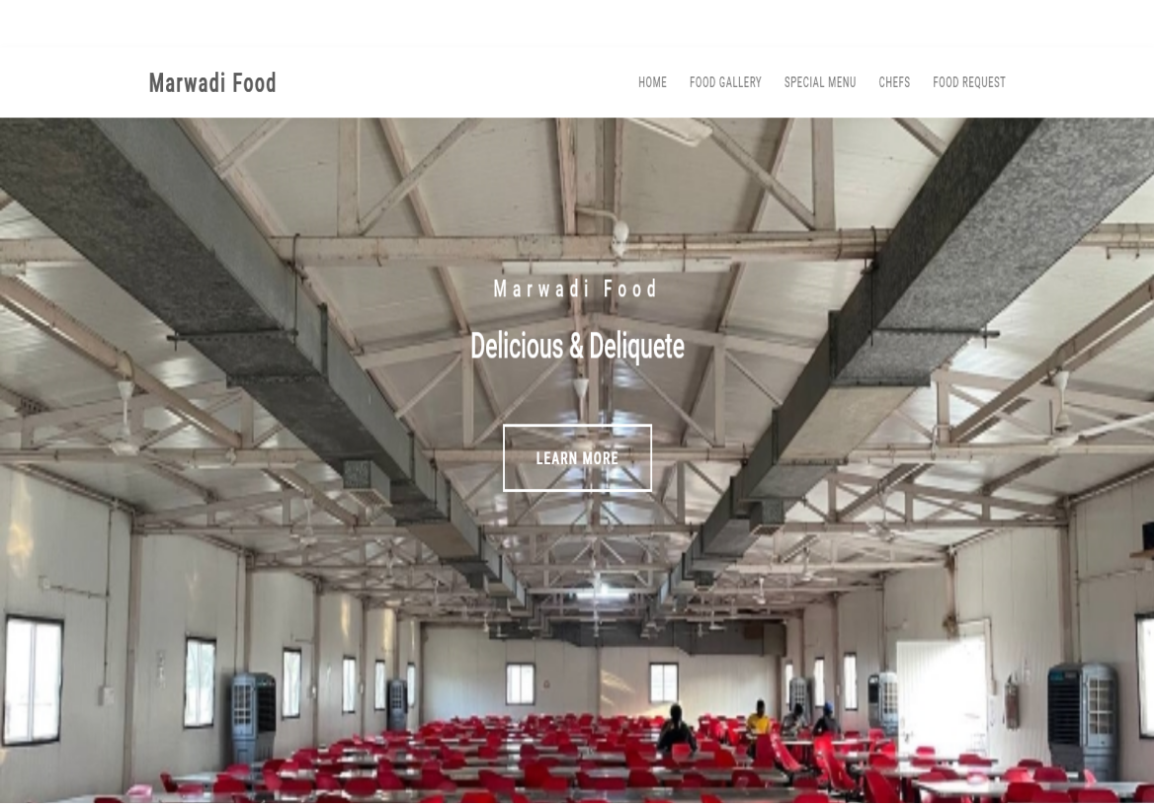

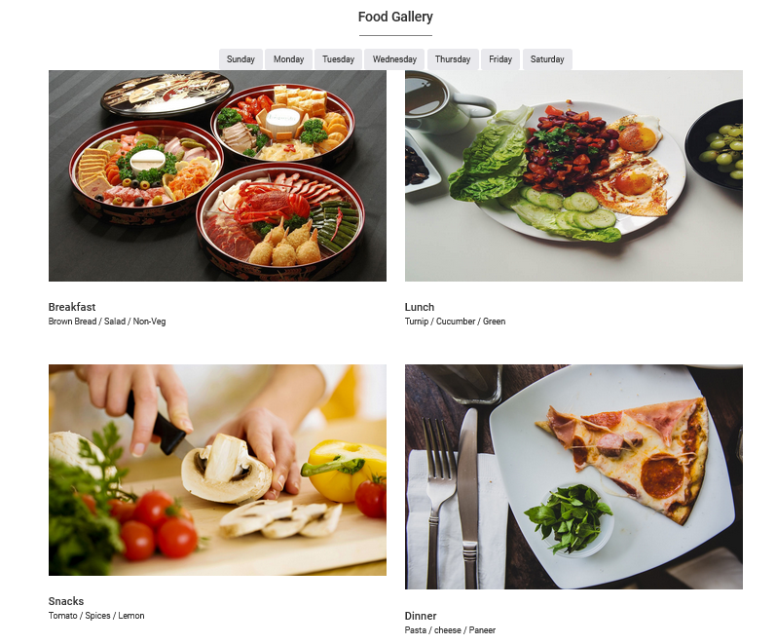

**Chapter 4: Implementation**

**4.1 Implementation Platform / Environment**

The application has been implemented using Visual Studio Code IDE. It is an advance IDE that can be used for creation of application using different technology. It has feature to enable different extensions for different technologies along with code correction and recommendation extension for better user interaction. In order to complete the project python has been used along with flask in the IDE.

**Chapter 5: Testing**

**5.1 Testing Plan / Strategy**

Testing of the application is necessary in order to know if the application is running as expected and is not broken in any way. The plan to test the project is simple i.e., to check the flow of the data in the application. First the normal front-end pages can be checked for any broken links or forms. Then we can check the login and register page of the application. After that the application can be checked for the dashboard part and functionalities like profile creation, updating profile, meetups etc is working properly. We can check if the model is working properly or not.

**5.2 Test Results and Analysis**

**5.2.1 Test Cases (test ID, test condition, expected output, actual output, remark)**

**Test Sample/Cases:**

|  |  |
| --- | --- |
| **Name of test** | **Registration** |
| **Feature being tested** | **Whether system is able create user Account.** |
| **Sample input** | **Allow user to register on providing specific information.** |
| **The expected output** | **User account should be created.** |
| **The actual output** | **User account is created successfully or error if user is not providing correct information.** |
| **Remark** | **Module is working properly.** |

|  |  |
| --- | --- |
| **Name of test** | **Database** |
| **Item/Feature being tested** | **Whether system is store data in database.** |
| **Sample input** | **Allow user to store data in database.** |
| **The expected output** | **User should be able to store data in database.** |
| **The actual output** | **User is able to store data.** |
| **Remark** | **Module is working properly.** |
| **Pass/Fail?** | **Pass** |

**Chapter 6: Conclusion and Discussion**

**6.1 Overall Analysis of Project Viabilities**

This project aims to provide and develop the Canteen/Mesh daily food menu and ordering

system .The development of this website needs the resource of daily analysis of food

system in university and be responsive according to the food management committee. The

development of this project will include the assessment from the food department, students

reviews, mesh staffs/workers and some of the faculties as well. Then analysing from the

software development methodologies we are involving different approach on management

in food and menu sector in our next step through implementing it in web based application.

Since the previous apps and websites regarding to our university food were not able to

perform well as they have not been updated from a long time so the students and the

faculties were unable to get the information about the food which is available at a particular

date in a mesh. This project will include food menu list for four times meal of a day i.e.

(breakfast, lunch, snacks and dinner) provided by the university food department.

**6.2 Problem Encountered and Possible Solutions**

Our website will take care of feedbacks of the food consumers as there was no any proper review system earlier in our university. Earlier if there were any changes made in the food menu then there were no any updates made or no any notification in the existing systems so the consumers would have to face various problems. The User Interface (UI) of previous system were not so interactive and informative to the users. So the user were not much interested in those system. There were no any proper facilities to inform food department about the student/consumers information when they were having some health issues due to which they were unable to have meals at proper time leading further illness to the consumer. The previous system were only targeted to hostel students neglecting the other consumers like faculties and out of hostel students. Since the previous system was app based so the user need to download it and the loading of the app consumed more time moreover this wasted their precious time being user unfriendly too.

**6.3 Summary of Project work**

There are currently many system available in the market. The solution has their own pros and cons. The existing system has been used by many but under the pressuring circumstances which can be overcome by the proposed system. The available solution to online daily food menu and food ordering system has given good benefits, but it comes with much more drawbacks of their own like high price for using the services available on the platform and also the less range of users for the application.

This project aims to remove these all problems and implement a system that can be easily used by the people and not have to waste their much time. The project reduced the traditional methods of working of application and is made full dynamic using new technologies. Admin can dynamically change, delete or add anything in the application. Website is more user interactive. Many functionalities like feedback and food requesting/ordering systems are added which makes it more effective.

**6.4 Limitation and Future Enhancement**

The project has few limitations to it such as lack of proper methods for handling the huge amount of requests if requested. Also the website can be made an android application in future since it is currently an web application only. We can work on the designing section of the website front end and make it more attractive in future.We can add some features like live chatting system for the consumers in future which will solve various real time problem immediately. We can add some visuals and videos in the website in future to make our users more engaged in future with some musics as well.We also can design a good logo and a good name in future for our website if necessary.

**References**

1. MU FOOD (Avalable in Playstore owned by Marwadi University)
2. Swiggy Application (for requesting/ordering food system)
3. [www.w3school.com](http://www.w3school.com)
4. [www.javatpoint.com](http://www.javatpoint.com)
5. [www.mysql.com](http://www.mysql.com)